North Star Software Developers (NSSD)

Network Security Training Manual

Jeremy Willett

Contents

Executive Overview 3

Purpose 3

Network Defense Assessment 3

Mitigation Assessment 4

Incident Response Assessment 5

Section One: Traffic Analysis 7

Traffic Analysis – Captured Packets: 7

Traffic Analysis – Alert Response 12

Section Two: Firewall Configuration 13

Firewall Configuration and Rule Creation: 13

Firewalls: Blocking, Allowing, and Filtering Traffic 19

Segmenting Networks 21

Guidelines for Implementation of Methods for Detecting Attacks 23

Section Three: Intrusion Detection 25

Whitelisting and Blacklisting Configuration 25

IDS Placement 29

Summary of Key Aspects of Monitoring, Logging (Auditing), and Alerting Using IDS 30

Section Four: Vulnerability Assessment 32

Vulnerability Assessment Implementation 32

Port Scanning 33

Device Scanning 36

Vulnerability Assessment/Penetration Testing 39

Interpreting Vulnerability Assessment Report/Identifying Weaknesses 44

Section Five: Network Scanning 46

Network Scanning Processes 46

Viewing Network Topologies 51

Network Scanning Interpretation 55

Section Six: Auditing and Log Collection 58

Auditing Tools 58

Recommended Network Tools Overview and Rationale 60

Works Cited 64

# Executive Overview

Purpose:

This manual is intended to provide guidance to employees to be able to detect, address, and respond to threats to the company network that may arise from any number of malefactors. This manual will outline the use and implementation of traffic analysis tools, firewalls, intrusion detection systems, vulnerability assessments, network assessments, auditing, and log collection. These systems and tools are vital in crafting, maintaining, and facilitating strong defensive strategies to protect the company and its assets. Threats can come from anywhere; in today’s world, no company is safe without proactively working to defend and maintain their networks with the intention of protecting company assets and data. As a software development company, North Star Software Developers (NSSD) has a responsibility to its shareholders and its customers to protect any sensitive information and data assets that are shared with the company. By providing employees with the training and supplemental materials necessary to effectively monitor and defend the company cyber infrastructure, the company addresses that responsibility and facilitates the development of a security culture in which all employees are responsible for security and defense.

Failure to appropriately apply training and use supplementary resources, such as this manual, to maintain a high-quality defense and mitigation strategy leaves the company vulnerable to threats seeking to infiltrate and steal sensitive information. By allowing this vulnerability, the company fails to honor its responsibility to protect client information and puts the company at risk of attack and losses that come in the form of financial and contractual liabilities. As a software development company, clients put their trust in NSSD with the sensitive information necessary to complete the desired software systems. This manual is intended to help to prevent these issues from arising by arming all necessary employees with the information, resources, and recommendations they need to be able to monitor the company network for potential threats and initiate the proper alert procedures to respond to the identified threats. This manual further recommends standard operating procedures for the use and implementation of firewalls and intrusion detection systems. Lastly, this manual offers guidelines for performing network and vulnerability assessments on a regular basis and provides the steps necessary to collect network logs and inspect audit trails to minimize the consequences of incident events.

This manual acts as guideline for how to protect the company and provides steps every employee can follow to properly protect and defend the company, its networks, and its assets from attack, whether internal or external. By updating the company policy to include the recommended changes and implementing this manual as a new standard operating procedure (SOP), the company looks to learn from recent breaches, adapt their policies and procedures, and prevent future attacks from occurring to the best of their ability.

Network Defense Assessment:

Network defense methods and strategies play a crucial role in securing a network by protecting it against various types of cyber-attacks. These methods and strategies include:

1. Firewalls: Firewalls are a key component of network security that helps to control incoming and outgoing traffic. They can be configured to block specific types of traffic or to allow only authorized traffic to pass through (Chen, 2018).
2. Intrusion Detection and Prevention Systems (IDPS): IDPS are designed to detect and prevent unauthorized access to a network. They can be configured to alert administrators of suspicious activity and take automated actions to block it (Kabay, 2020).
3. Virtual Private Networks (VPNs): VPNs are used to create secure, encrypted connections between devices over the internet. They can be used to protect against eavesdropping and to secure remote access to a network (Kabay, 2020).
4. Access control: Access control is used to restrict access to a network based on the identity of the user or device. This can be implemented using authentication methods such as passwords or biometrics, or by using network access control (NAC) solutions that check the security posture of a device before allowing it to connect to the network (Chen, 2018).
5. Network segmentation: Network segmentation is the process of dividing a network into smaller subnetworks, each with its own security controls. This can help to limit the damage caused by a security breach by isolating it to a specific segment of the network (Kabay, 2020).
6. Security Information and Event Management (SIEM): SIEM solutions collect, correlate, and analyze security-related data from various sources to provide a comprehensive view of the security posture of a network (Chen, 2018).
7. Patch management: Regularly updating the software and firmware on network devices can help to address known vulnerabilities and prevent them from being exploited by attackers (Kabay, 2020).
8. Incident Response plan: Having a well-defined incident response plan in place can help to minimize the damage caused by a security breach and to quickly restore normal network operations (Chen, 2018).

Network defense methods and strategies are essential for protecting a network against cyber threats and ensuring that it remains secure and available to authorized users.

Mitigation Assessment:

Mitigation methods and strategies play a crucial role in reducing security risks by identifying potential vulnerabilities and taking steps to address them. These methods and strategies include:

1. Risk assessment: Risk assessment is the process of identifying, evaluating, and prioritizing potential security risks (ISO, 2019). This can be done through various techniques, such as threat modeling or vulnerability scanning, and is an important step in identifying the areas of the system or network that are most in need of protection.
2. Vulnerability management: Vulnerability management is the process of identifying, evaluating, and mitigating vulnerabilities in a system or network (NIST, 2020). This can include patching known vulnerabilities, implementing security controls to prevent exploitation, and monitoring for new vulnerabilities.
3. Security controls: Security controls are methods or technologies that are implemented to protect a system or network from security risks (ISO, 2019). These can include firewalls, intrusion detection systems, access controls, and encryption.
4. Incident response plan: Having an incident response plan in place can help to minimize the damage caused by a security breach and to quickly restore normal operations (NIST, 2020). This plan should include procedures for identifying and containing an incident, as well as for responding to and recovering from it.
5. Security testing: Security testing is the process of evaluating the security of a system or network by simulating real-world attack scenarios (NIST, 2020). This can include penetration testing, vulnerability scanning, and security audits, and can help to identify and address vulnerabilities before they are exploited by attackers.
6. Employee Training: Employee training is an important aspect of security, educating employees on security best practices and awareness can help prevent successful attacks (NIST, 2020).

Mitigation methods and strategies are essential for reducing security risks by identifying and addressing vulnerabilities, implementing security controls, and preparing for and responding to security incidents.

Incident Response Assessment:

Incident response methods and strategies play a crucial role in minimizing the impact of security breaches by identifying and containing an incident, responding to it, and recovering from it. These methods and strategies include:

1. Incident detection and reporting: Incident detection and reporting is the process of identifying and reporting security incidents in a timely manner (NIST, 2016). This can include monitoring for suspicious activity, implementing security controls to detect and prevent attacks, and having a reporting mechanism in place for employees to report incidents.
2. Incident triage: Incident triage is the process of evaluating the severity of an incident and determining the appropriate response (SANS Institute, 2020). This can include determining the scope of the incident, identifying the assets that are affected, and determining the level of urgency for response.
3. Incident containment: Incident containment is the process of isolating and containing an incident to prevent it from spreading (NIST, 2016). This can include disconnecting affected systems from the network, shutting down services, or implementing security controls to prevent further compromise.
4. Incident response: Incident response is the process of taking action to address an incident, including conducting forensic analysis, identifying the cause of the incident, and taking steps to prevent it from happening again (SANS Institute, 2020).
5. Incident recovery: Incident recovery is the process of restoring normal operations after an incident has occurred (NIST, 2016). This can include restoring systems and data, testing systems to ensure that they are functioning properly, and reviewing incident response processes to identify areas for improvement.
6. Post-Incident review: post-incident review is the process of reviewing the incident and the incident response process, to identify the areas that can be improved and make necessary changes (NIST, 2016)

Incident response methods and strategies are essential for minimizing the impact of security breaches by identifying and containing incidents, responding to them, and recovering from them.

# Section One: Traffic Analysis

## Traffic Analysis – Captured Packets:

Traffic Analysis is the process of capturing and analyzing Internet Protocol packets on a network. “Capturing packets is a common troubleshooting technique for network administrators and is also used to examine network traffic for security threats. Following a data breach or other incident, packet captures provide vital forensic clues that aid investigations” (Grimmick, 2021). When attempting to view what is going on over a network, tools need to be implemented to allow for traffic passing over the network to be viewed. Capturing, viewing, and monitoring network packets using network packet sniffing tools gives the ability to analyze the data generated by network traffic for employees to identify potential malicious activity. Packet capture files, also known as PCAP files, are files generated by network analyzing tools to collect and record data from the network. NSSD employees should utilize the tools Wireshark and Network Miner to generate these files and analyze their contents. “There are many reasons why PCAP is used to monitor networks. Some of the most common include monitoring bandwidth usage, identifying rogue DHCP servers, detecting malware, DNS resolution, and incident response. For network administrators and security researchers, packet file analysis is a good way to detect network intrusions and other suspicious activity. For example, if a source is sending the network lots of malicious traffic, you can identify that on the software agent and then take action to remediate the attack” (Keary, 2022).

The goal of utilizing a packet sniffer like Wireshark and a network analysis tool like Network Miner is to monitor the company network for any anomalies that may suggest potential threat actors working on the network. “The biggest advantage of packet capturing is that it grants visibility. You can use packet data to pinpoint the root cause of network problems. You can monitor traffic sources and identify the usage data of applications and devices. PCAP data gives you the real-time information you need to find and resolve performance issues to keep the network functioning after a security event. For example, you can identify where a piece of malware breached the network by tracking the flow of malicious traffic and other malicious communications. Without PCAP and a packet capture tool, it would be more difficult to track packets and manage security risks” (Keary, 2022). While packet capturing will not allow encrypted communications to be viewed in plain text, A network sniffing tool can be used to point in the direction of suspicious activity on the network to suggest something nefarious is happening on the network.

Using Wireshark to actively monitor network traffic gives employees the ability to look for anomalies on the network, however it is not responsible for someone to always be watching the endless traffic occurring on the network. For this reason, packets can be captured and stored for later analysis. This is where Network Miner is used because of the organization it provides in displaying the data. PCAP files are pasted into Network Miner and the software will sort the information in the file for an employee to review without having to go through each file associated with the capture. This tool allows some leeway for employees to be able to view network captures in an organized fashion without needing to know the specifics of how to sort through a large capture file.

To begin, we will set up the sniffer, Wireshark, to be able to look at the network and monitor traffic.

1). Begin by logging into the Kali Linux Virtual Machine, On the login screen, **select** Other.

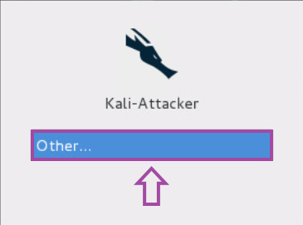

2). When presented with the username, **type** root. **Press** Enter.

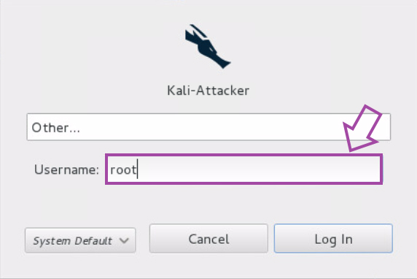

3). When prompted for the password, **type** toor. **Press** Enter.

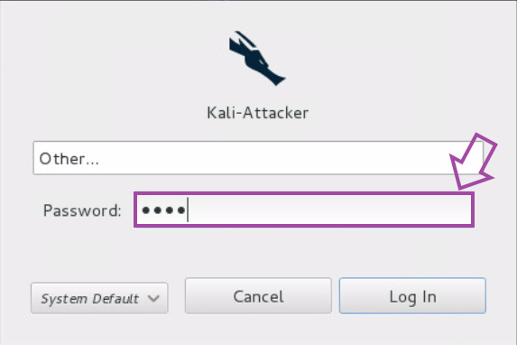

4). **Click** the black and white icon (second from the top) to launch the Linux terminal.

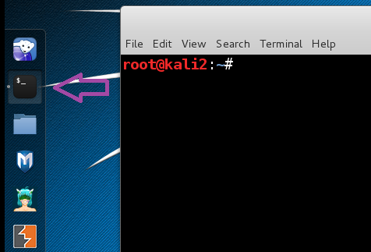

5). **Type** the following command and **press** Enter, to check for the IP Address of the system.

root@kali2:~# ifconfig

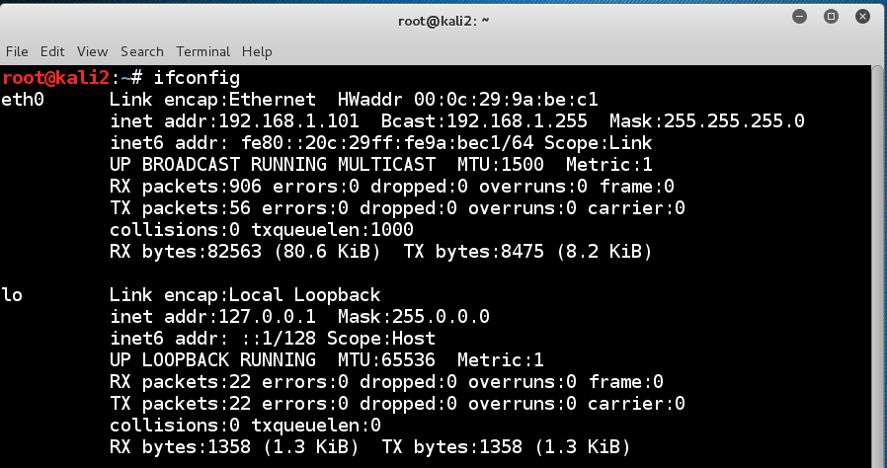

6). **Type** the following command and **press** Enter, so your system will not have an IP Address.

root@kali2:~# ifconfig eth0 0.0.0.0 up



7). **Type** the following command and **press** Enter, to verify that no IPv4 address is listed for eth0.

root@kali2:~# ifconfig

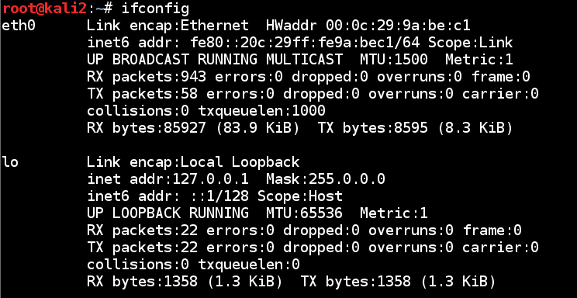

8). **Type** the following command and **press** Enter, to open Wireshark.

root@kali2:~# wireshark

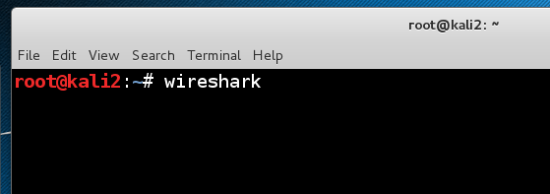

9). **Select** Capture from the Wireshark menu and **choose** Interfaces.

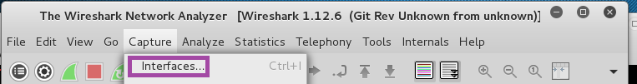

10). **Select** the check box in front of eth0. **Notice** in the IP column it says none. **Click** Start.

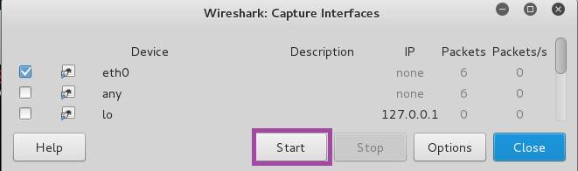

11). After a short while, packets should start appearing in the Packet List.

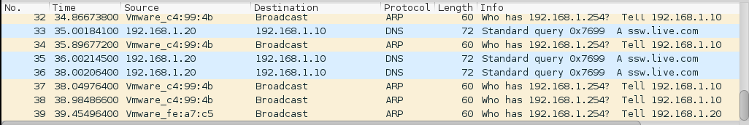

With Wireshark enabled and set up, employees can utilize this to look at traffic from various sources and destinations and monitor what is happening on the network. Wireshark commands can be utilized for various information. To see Wireshark commands and uses, refer to the Wireshark reference documentation.

Traffic Analysis – Alert Response:

Recognizing and identifying traffic anomalies on the company network is vital to protecting the company network and its data. Through active traffic monitoring with Wireshark and network log analysis with Network Miner, employees can identify suspicious activity. Once identified, it is important that the activity in question is reported to enable the company and its security team to respond accordingly. At this point, the reporting of identified anomalies should be escalated to the Incident Response Team. This team is responsible for determining if the reported anomaly is an indicator of a security incident occurring. The National Institute of Standards and Technology (NIST) acknowledges that determining if every indicator presented is evidence of a cyber incident occurring, however, it still recommends that the Incident Response Team work to determine if anomalies and suspicious activity are indicators. “In incident handling, detection may be the most difficult task. Incident handlers are responsible for analyzing ambiguous, contradictory, and incomplete symptoms to determine what has happened. The best remedy is to build a team of highly experienced and proficient staff members who can analyze the precursors and indicators effectively and efficiently and take appropriate actions. Without a well-trained and capable staff, incident detection and analysis will be conducted inefficiently, and costly mistakes will be made” (Cichonski, Millar, Grance, & Scarfone, 2012).

Every moment is crucial when responding to a cyber incident. For this reason, reporting potential suspicious network activities and anomalies on the company network is vital to allow the Incident Response Team the opportunity to respond to the threat as quickly as possible. “The incident response team should work quickly to analyze and validate each incident, following a predefined process and documenting each step taken. When the team believes that an incident has occurred, the team should rapidly perform an initial analysis to determine the incident’s scope, such as which networks, systems, or applications are affected; who or what originated the incident; and how the incident is occurring (e.g., what tools or attack methods are being used, what vulnerabilities are being exploited). The initial analysis should provide enough information for the team to prioritize subsequent activities, such as containment of the incident and deeper analysis of the effects of the incident” (Cichonski, Millar, Grance, & Scarfone, 2012). As employees recognize and identify anomalies as they monitor network traffic, properly communicating their findings to the appropriate team can limit the impact of a security event and reduce the effect it has on the company. For this reason, no report should be taken lightly, and any suspicious activity should be reported and never disregarded as minute or unimportant.

# Section Two: Firewall Configuration

## Firewall Configuration and Rule Creation:

A firewall acts as the first line of defense of network traffic entering and exiting the company network. A firewall can be configured to redirect traffic, allow, or deny certain access, or determine the types of traffic to allow to pass on the network based on their type, source, or destination.

NSSD utilizes the pfSense firewall. This guide is designed to illustrate to employees the initial configuration of the firewall, as well as how to create new rules for the firewall, apply traffic filtering settings, segment the network, and how to implement detection methods for attacks.

Step 1). While logged into an NSSD windows computer, open a Firefox browser window and **type** **192.168.1.254** in the URL bar at the top of the window. When prompted to login, enter the following and **click** **Login**:

**Username**: admin

**Password**: pfsense

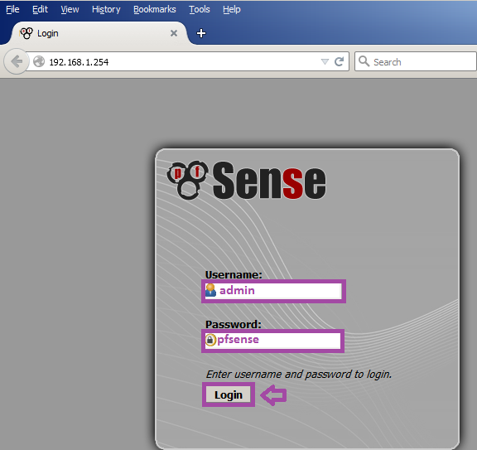

Step 2). Navigate to the **System** dropdown menu and select **Setup Wizard. Click Next** on the next two screens that show. The **General Information** screen should auto-populate. Validate the following are entered:

**Hostname**: pfsense

**Domain**: university.edu

**Primary DNS Server**: 192.168.1.100

**Override DNS**: checkmark in box

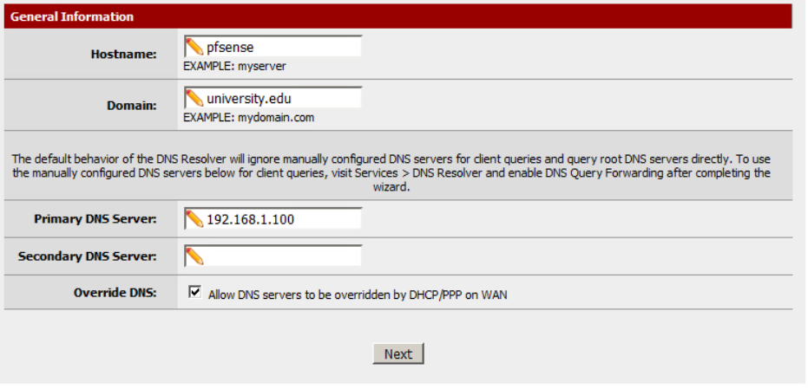

Click **Next** when the fields have been validated.

Step 3). Set the **Time server hostname** and the **Time zone** to the following:

**Time server hostname**: 0.pfsense.pool.ntp.org

**Time zone**: Etc/UTC

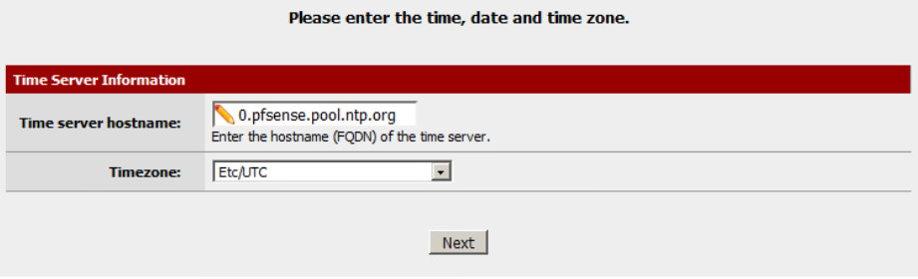

Click **Next.**

Step 4). Set the **WAN Interface** to Static and enter the following in the corresponding fields.

**IP Address**: 203.0.113.100

**Subnet Mask**: 24

**Upstream Gateway**: 103.0.113.254

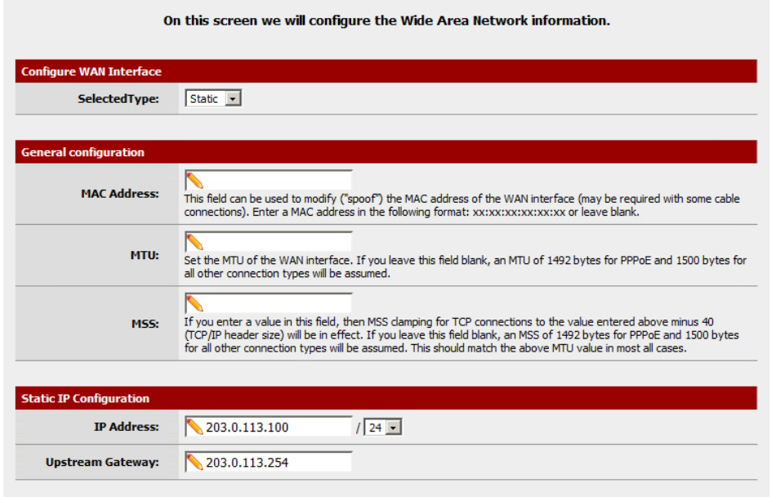

Leave all other fields blank and click **Next**.

Step 5). Validate the **LAN IP Address** and **Subnet Mask** fields match the following:

**LAN IP Address**: 192.168.1.254

**Subnet Mask**: 24

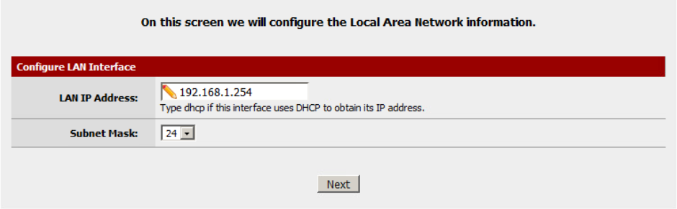

Click Next.

Step 6). Set the **Admin Password** to pfsense and re-enter it in the second field.

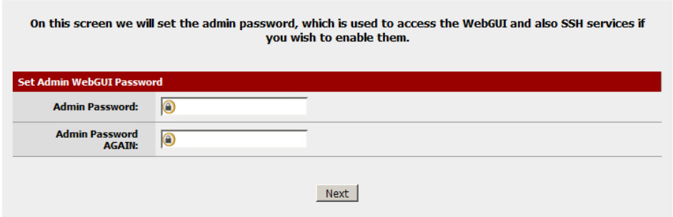

Click **Next**.

Step 7). Click **Reload**.

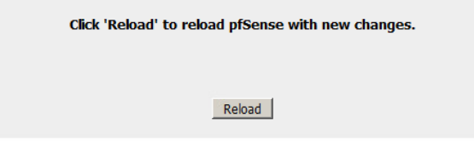

Step 8). Once you see the following screen:

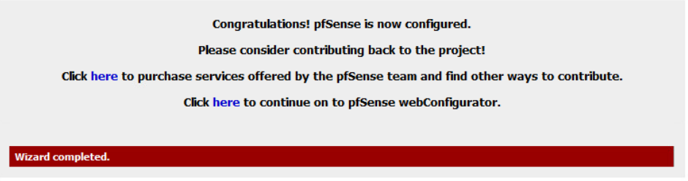

Click on the pfSense logo to return to the home page. The initial firewall configuration is now complete.

Next, we need to check to make sure there are no unnecessary ports open and that only authorized traffic types are forwarded to the server.

Step 1). From the **Firewall** dropdown menu, click **NAT**.

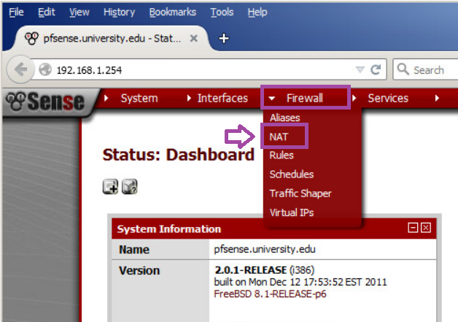

Step 2). Check all protocols except TCP 443(HTTPS) and 3389 (MS RDP). Then click the upper righthand X to remove.

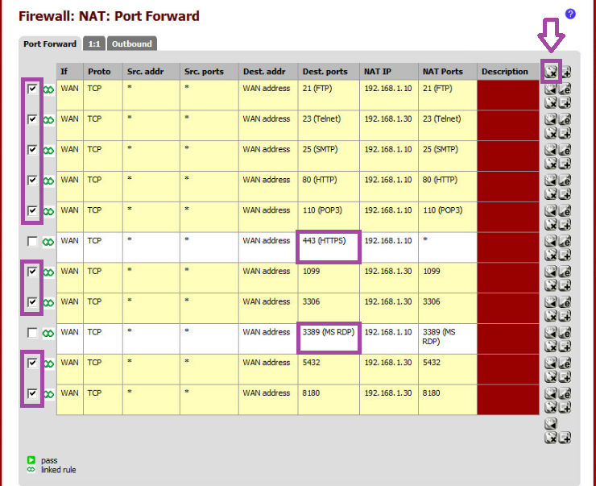

Click OK when you are asking if you really want to delete the selected rules.

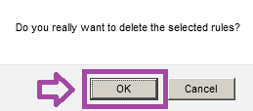

Step 3). Click **Apply changes** to save the changes we made to the list.

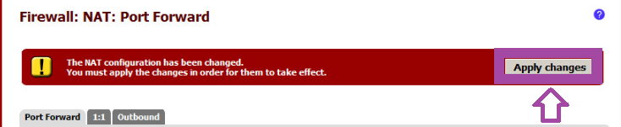

Step 4). Next, we will add a rule to forward all SSH traffic to the company designated server. Click the **+** button in the upper righthand corner.

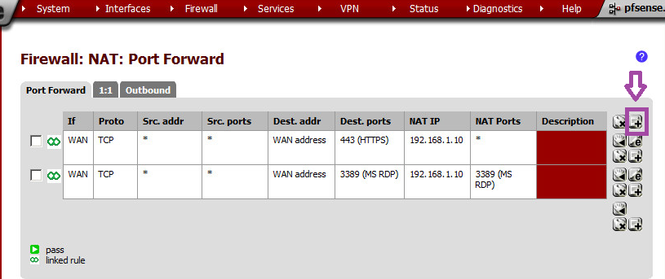

Step 5). Under **Destination port range**, click the dropdown box and select SSH (for to and from). In the **Redirect target IP**, type 192.168.1.30. In the **Redirect target port** box, type 22. **Click** the Save button.

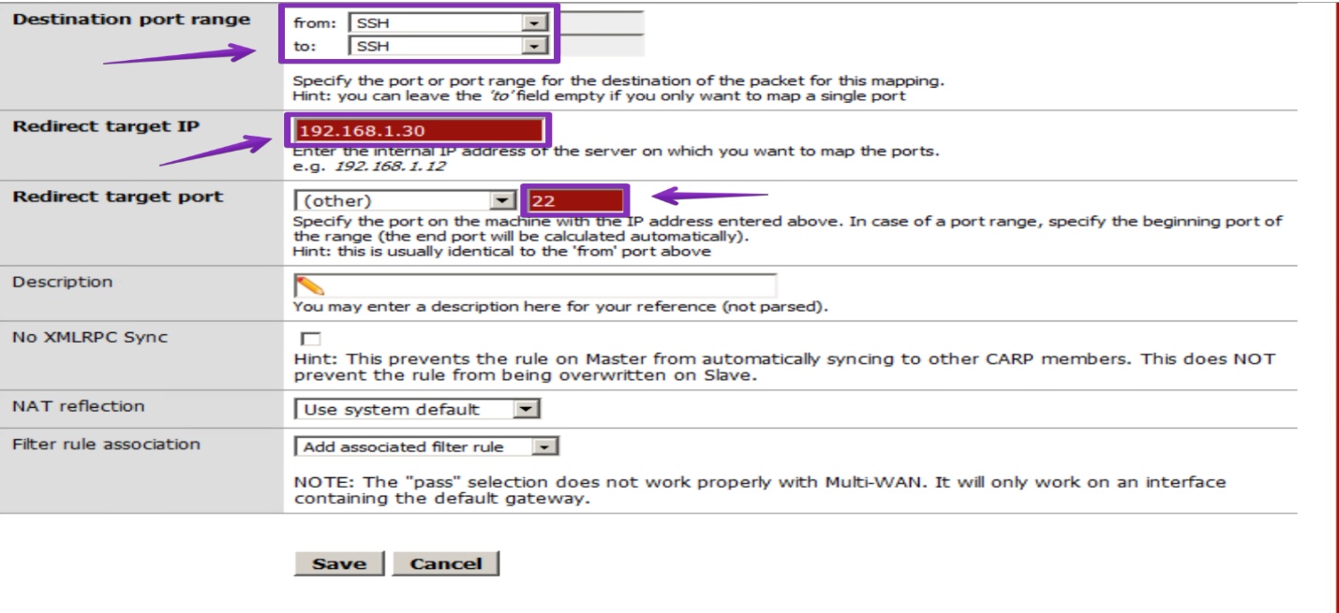

Step 5) Click **Apply changes** to save the addition to the list.



The Port Forwarding Rule creation is completed. Please ensure you receive an **applied successfully** message and test the rule.

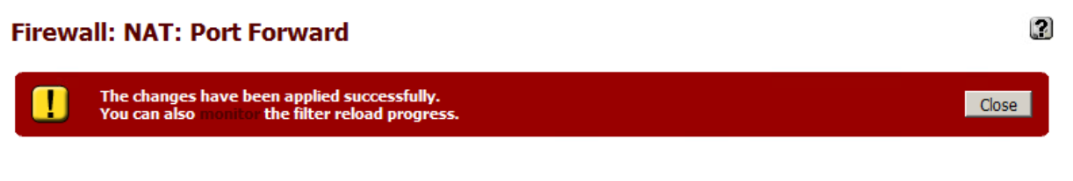

Firewalls: Blocking, Allowing, and Filtering Traffic:

In this section, the process for allowing, blocking, and filtering network traffic based on type will be illustrated. This will walk through an example of applying a firewall rule to block common traffic types that are insecure and should not be used to transmit data such as FTP. FTP transmits data in plain text across the network, so anyone monitoring could intercept and see the data being transmitted. For this reason, NSSD does not authorize the use of this protocol so we will block it from the network.

Step 1). Click **Firewall** dropdown menu and select Rules.

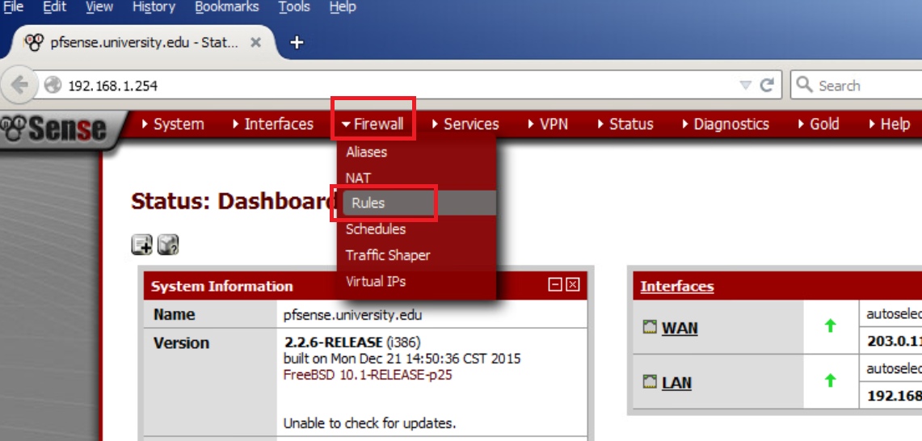

Step 2). Click the plus sign in the upper righthand corner.

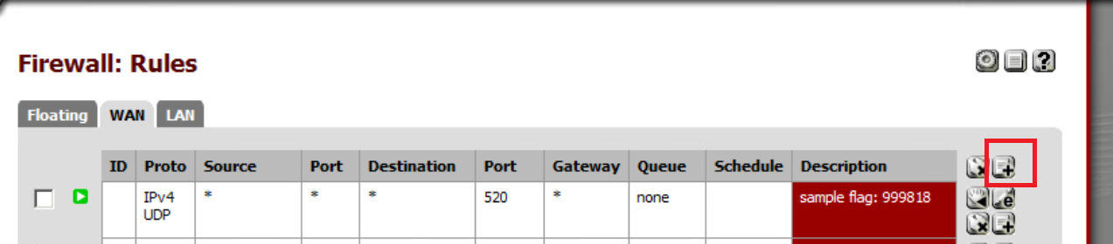

Step 3). FTP operates on port 21, when **allowing** a protocol to pass through the network, you will select Pass and select the type from the destination port range option. When **blocking** a protocol, you will select the Block action. For this protocol, set the following fields:

**Action: Pass**

**Interface: WAN**

**Protocol: TCP**

**Destination: Any**

**Destination port range: FTP(From and To)**

**Description: FTP Block**

Then hit **Save**

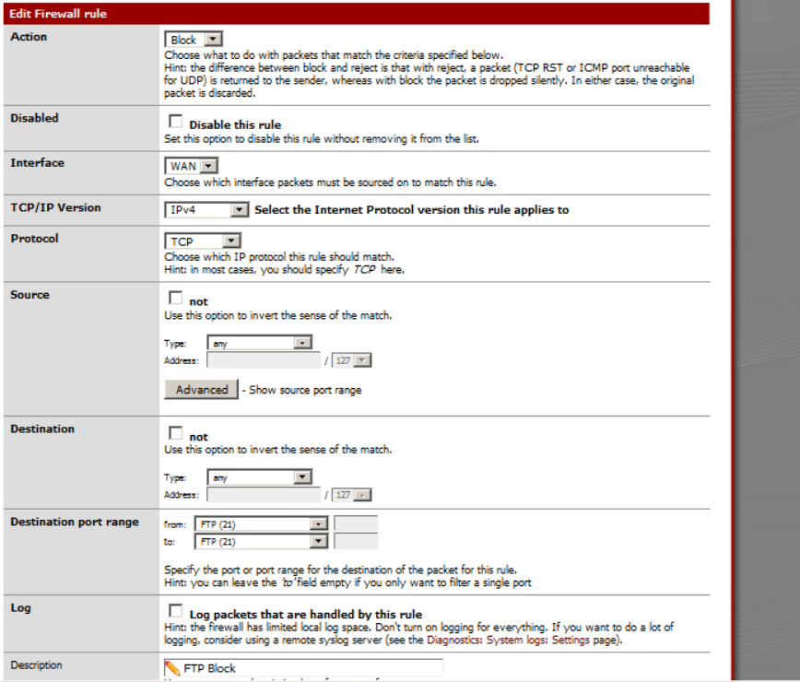

Step 4). **Click** Apply changes.

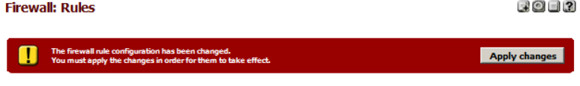

The firewall will now block all FTP traffic on the network. This same process can be used to create rules to allow or block any traffic types over their designated ports.

Segmenting Networks:

In this section, we will segment the company network by illustrating how to implement a VLAN to isolate part of the network to better control areas that handle sensitive information. The use of a VLAN allows us to apply stricter rules to the devices assigned to the VLAN and as a result, better protect the NSSD network and its data.

Step 1). From the **Interface** dropdown select **assign**

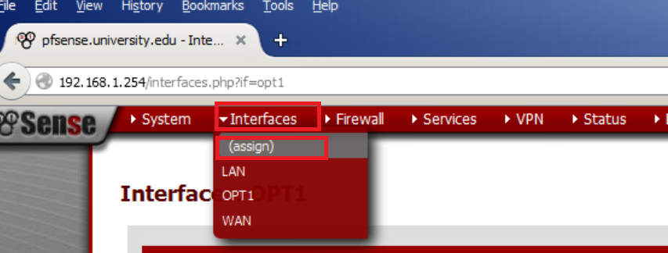

Step 2). Select the **VLANs** tab and hit the **plus sign**.

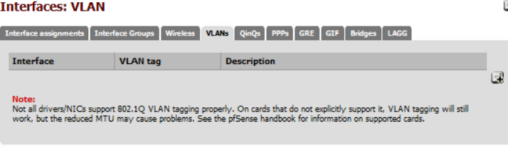

Step 3).Select **le0 interface**. For the VLAN tag enter **101** and type **Sensitive VLAN** in the description field.

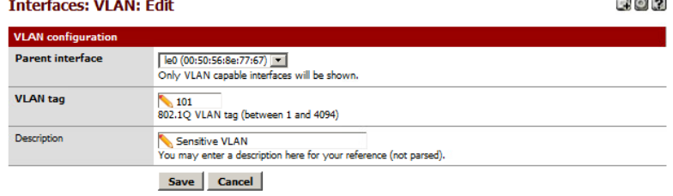Then hit **Save.**

Step 4). Click the Interface Assignments tab.

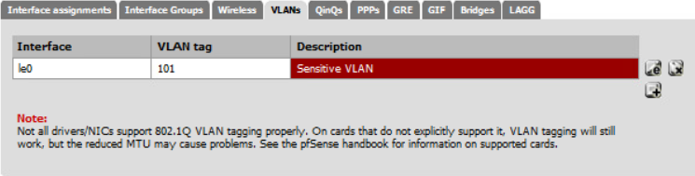

Step 5). Click the **plus sign** on the Available network ports line.



Step 6). Click **OPT1**.

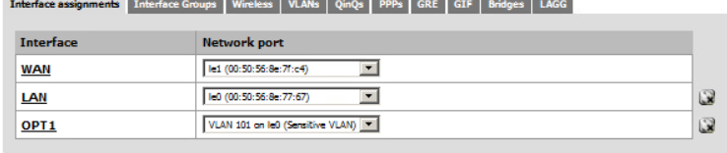

Step 7). Check the **Enable Interface** box and configure the following settings:

**Enable: Ensure this is checked**

**Description: P1LAN**

**IPv4 Configuration Type: Static IPv4**

**IP Address: 192.168.1.30 /32**

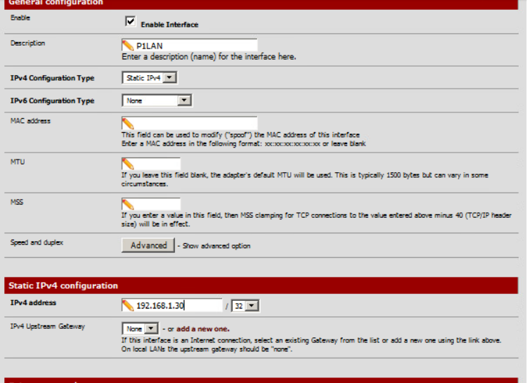

Then click the **Save** button.

Step 7). Click Apply changes.

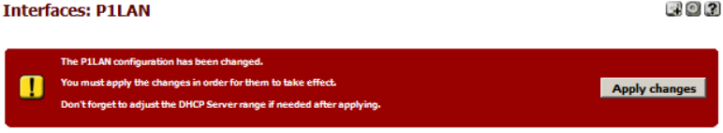

There will now be a new interface option called P1LAN. This can be selected when making rules to set rules specific to this VLAN. Since this network is designated for sensitive traffic, these rules should be kept strict to limit traffic to only secure and necessary traffic types (such as SSH and HTTPS).

Guidelines for Implementation of Methods for Detecting Attacks:

Monitoring a network for unusual traffic patterns and suspected malicious actions is necessary to keep any network secure. In the same way a security guard monitors cameras for a building, an Intrusion detection system (IDS) serves to monitor network traffic and notify the security team if anything questionable or unusual is occurring on the network. In the example of a medieval castle, a firewall is the mote surrounding the castle while an intrusion detection system is the guards posted on the turrets keeping watch over the area. Once the IDS identifies a suspicious pattern, it notifies the security team for them to investigate and intercede, hopefully in a timely manner.

Snort is a program that implemented with pfsense to add real time Intrusion detection and prevention to further reinforce security. Snort can operate on multiple interfaces (meaning it can monitor the entire network along with specific VLANS, such as the VLAN we set up for sensitive information). Snort provides alerts and is fully configurable to establish what it is monitoring and what it alerts for.

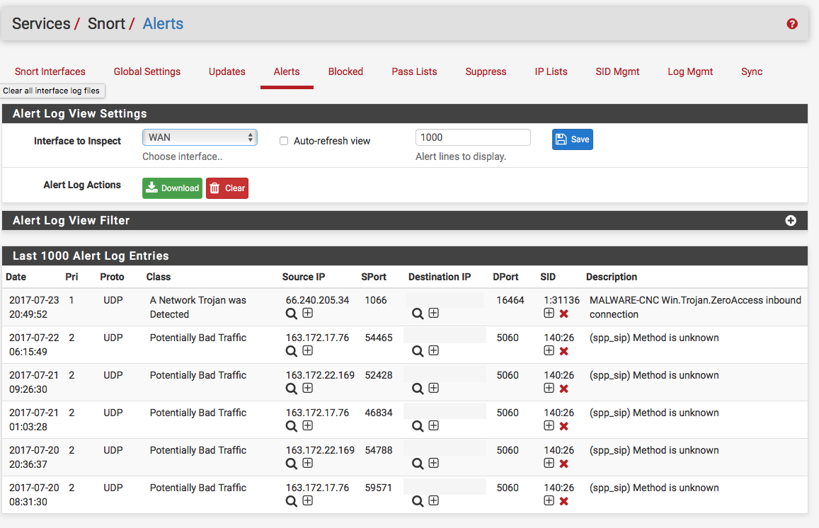

To install Snort on the pfSense firewall, navigate to the **System** dropdown menu and select Package Manager.

Once installed, the Snort Package can be further configured utilizing the documentation provided at <https://docs.netgate.com/pfsense/en/latest/packages/snort/setup.html>.

# Section Three: Intrusion Detection

## Whitelisting and Blacklisting Configuration

As previously mentioned, NSSD utilizes Snort in conjunction with the pfSense firewall. Snort is an intrusion detection and prevention system. It can be configured to simply log detected network events to both log and block them. Thanks to OpenAppID detectors and rules, Snort package enables application detection and filtering. This section will cover how to set up whitelists and blacklists in Snort to allow or block IP addresses on the system.

Step 1). While logged into an NSSD windows computer, open a Firefox browser window and **type** **192.168.1.254** in the URL bar at the top of the window. When prompted to login, enter the following and **click** **Login**:

**Username**: admin

**Password**: pfsense



Step 2). Navigate to the services drop down menu and click Snort.

Step 3). First, we will set up Whitelists for Snort to ensure allowed and needed sites are not blocked by Snort. Snort refers to this as a Pass List. Navigate to the Pass Lists Tab on the Snort services menu.

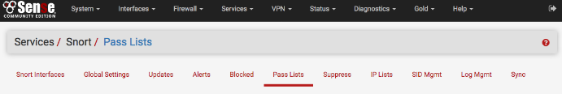

Step 4). A default Pass List is automatically generated by Snort for every interface, and this default list is used when no other list is specified. Customized Pass Lists can be created and then assigned to an interface. This might be needed when trusted external hosts are needed that are not located on networks directly connected to the firewall.

When creating a custom Pass List, leave all the auto-generated IP addresses checked in the Add auto-generated IP addresses section. Not selecting the checkboxes in this section can lead to blocking critical addresses including the firewall interfaces themselves. This could result in being locked out of the firewall over the network! Only uncheck boxes in this section when a valid need is present.

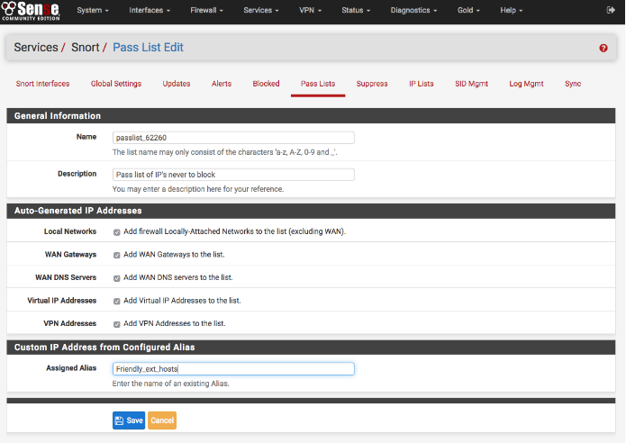

Step 6). Navigate to the Snort Interfaces Tab.

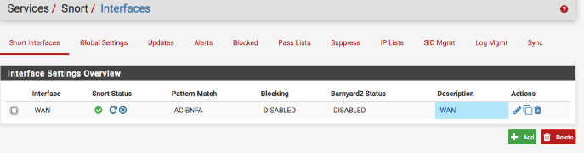

Step 7). Click the Pencil Icon next to the interface you want to assign the Pass List too.

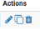

Step 8). Scroll until you see the Pass List setting and select the new Pass List from the drop-down menu. Click Save once selected.

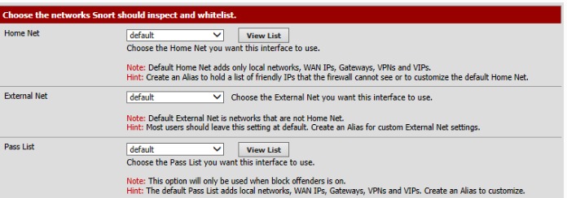

Step 9). Restart Snort to ensure the new Pass List settings take effect.

Next, we will move on the Blacklisting.

Step 1). Snort can blacklist IP addresses. It does this based on lists that it comes pre-loaded with as well as custom lists that can be made and added to the system. To add a new list, navigate to the IP Lists tab.



Step 2). To upload an IP list file to the firewall, click the  icon to open the file upload dialog as shown below. Browse to the file on the local machine using the **BROWSE** button, then click the **UPLOAD** button to upload the file to the firewall for use by the IP Reputation preprocessor in Snort.

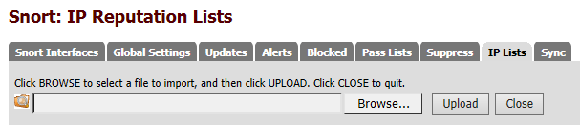

Step 3). To create a new IP list, click the  icon. To edit an existing IP list, click the  icon beside the list to edit. Click SAVE when finished to save changes to the list or CANCEL to abandon any changes.

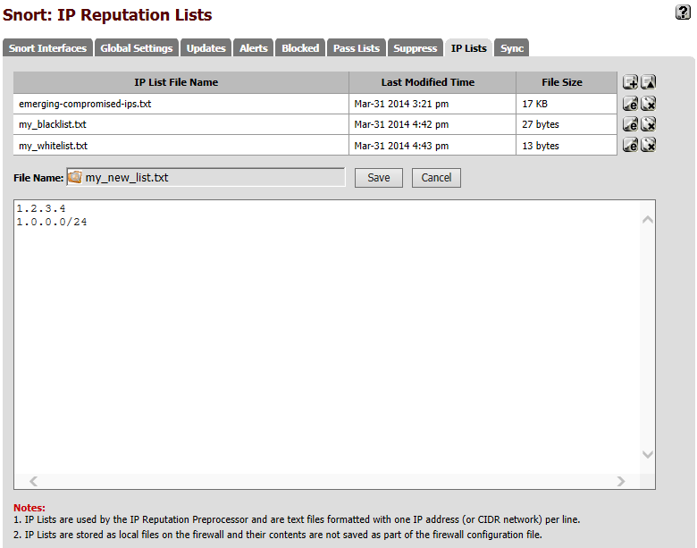

## IDS Placement

Snort operates in conjunction with the pfSense firewall that NSSD operates. A feature of snort is being able to turn the IDS on and off based on how the network is segmented by the pfSense firewall. This allows us to determine where we want the IDS to operate. It is NSSD’s policy to run Snort on all active network interfaces to detect any malicious traffic on the network. To ensure this is functional, follow these steps.

Step 1). While in the Snort services menu, select the Snort interfaces tab.

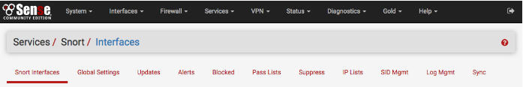

Step 2). This menu should show all interfaces currently active on the pfSense firewall. Check to ensure there is a green check mark next to each of the interfaces listed.

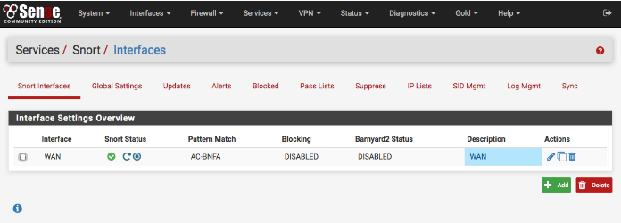

Step 3). If there is a yellow X next to the interface, Snort is not currently running and needs to be turned on.

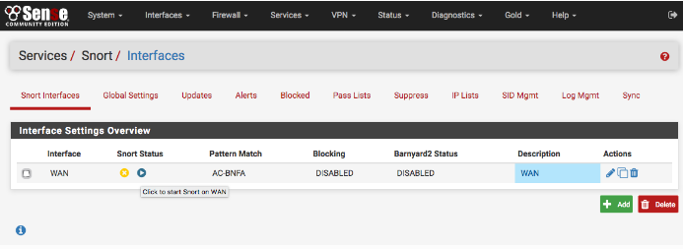

To enable Snort on these interfaces, mouse over the yellow X and click it. This will start Snort on the selected interface.

This completes the section on ensuring the Snort is operating on each area of the segmented network.

## **Summary of Key Aspects of Monitoring, Logging (Auditing), and Alerting Using IDS**

While Snort monitors the configured interfaces, it generates alerts and logs based on the rules it is set to monitor. The paid version of Snort that NSSD uses comes with pre-configured rules that are downloaded from Snort and implemented on the system. Based on these rules, Snort generates alerts that can be viewed under the corresponding tab. To view these alerts, follow these steps:

Step 1). While on the Snort services menu, select the Alerts tab.

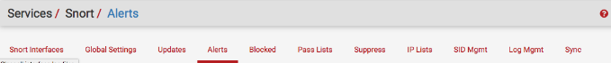

Step 2). From this menu, all Alerts for the selected interface can be viewed. To select an interface to view, click the drop-down menu next to Interface to Inspect and select the desired interface. In the following example, the WAN interface is selected.

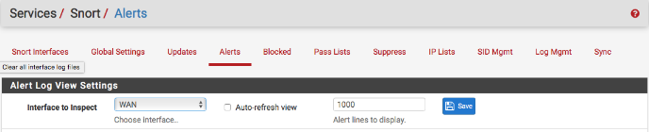

Step 3). To download the list of all alerts on the selected interface, click the download button next to Alert Log Actions.

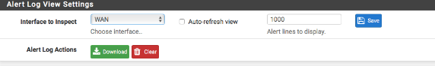

Step 4). Below the log view settings, you will see a list of all the alerts on the selected interface up to the designated amount.

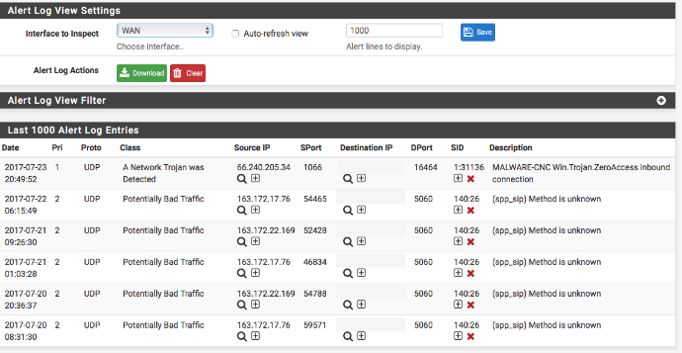

This information includes the data/time of the event, the protocol type, the source IP, source port number, Destination IP, destination port number, and a brief description of the alert.

# Section Four: Vulnerability Assessment

Vulnerability Assessment Implementation:

NSSD utilizes Nmap, Zenmap, OpenVAS, and the Greenbone Security Assistant all running on a Linux virtual machine that is set up outside the company network. This system is designed to be used as an attack machine to test for vulnerabilities on the NSSD network. To perform this vulnerability assessment, complete the following procedures.

1). Begin by logging into the Kali Linux Virtual Machine, On the login screen, **select** Other.



2). When presented with the username, **type** root. **Press** Enter.



3). When prompted for the password, **type** toor. **Press** Enter.



Port Scanning:

As part of a vulnerability scan, it is necessary to test the network for open ports to see if any ports are left open that leave the company’s network open to attack. To test for open ports, follow these steps:

1). While on the Kali system, **open** a new terminal window.

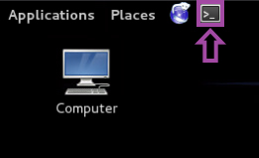

2). **Type** zenmap followed by **pressing** Enter in the terminal screen.

root@Kali-Attacker:~# zenmap

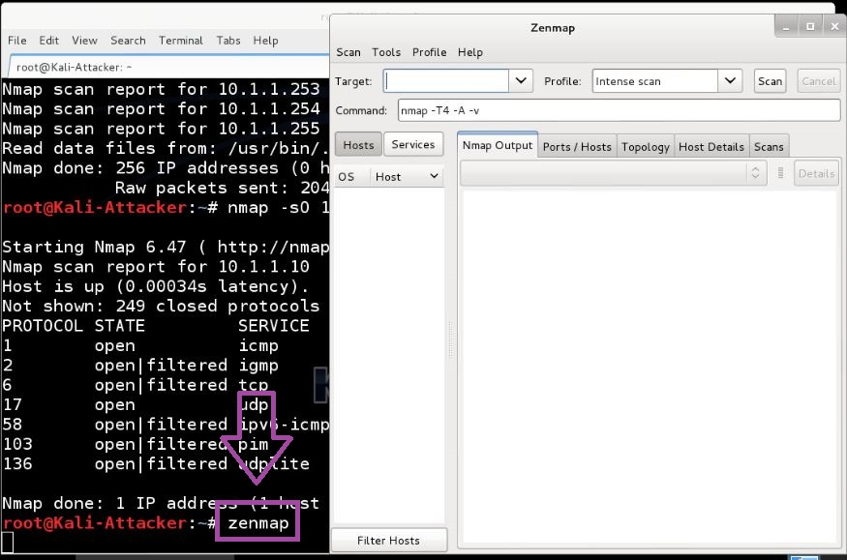

This will open Zenmap, a GUI to allow for scanning of the network in a layout that is easier to interpret. With this software we will scan the multiple networks on the NSSD network to determine the open ports. This example uses sample IP addresses. To get the correct IP addresses for the company, refer to the company Network IP address documentation.

3). **Initiate** a new Zenmap scan for both networks: 192.168.1.0/24 and 10.1.1.0/28. **Type** 192.168.1.0/24 10.1.1.0/28 in the Target field. 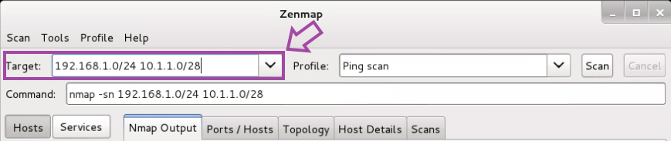

4). **Choose** Ping scan from the Profile drop-down menu.

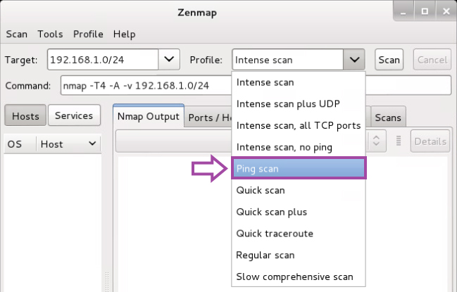

5). In the Command field, **type** the following command:

nmap -T5 192.168.1.0/24 10.1.1.0/28

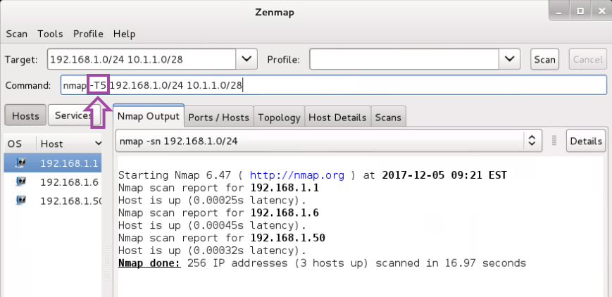

6). **Click** Scan.

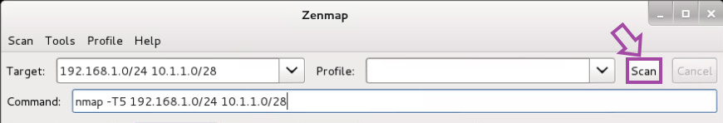

7). On the left side of the output, you will see a list of Hosts. These hosts are all the IP addresses you entered as part of the scan. **Click** on the host you would like to inspect. Next, **click** on the Ports/Hosts tab and **view** the specific opened ports for that particular host.

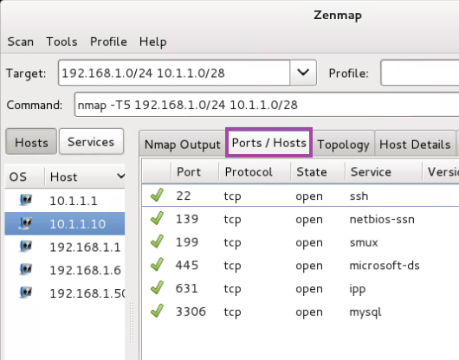

8). Repeat this step for each host to determine the open ports on the network. Compare this with the company policy on specified open ports to ensure only the designated ports are open.

**This completes the procedure for port scanning**.

Device Scanning:

To perform device scanning, we will utilize Nmap, the command line version of Zenmap. Our goal with this scan is to determine any information we can about a system to provide any information that may aid an outside attacker.

1). While on the Kali system, **open** a new terminal window.



2). **View** the available options that can be used with Nmap by **typing** nmap into the terminal followed by **pressing** Enter.

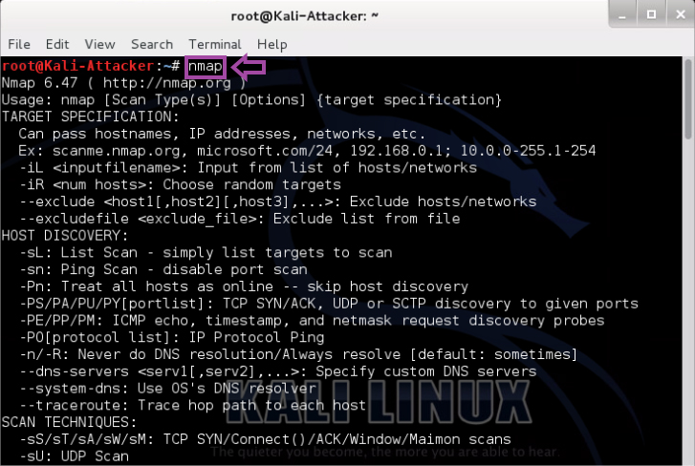

For this, we will be **using** the operating system scan function.

3). Perform this scan for each of the IP addresses used in the port scanning section. This example uses an example IP to show the expected results and use of the scan.

**Initiate** an operating system scan against the desired IP address to help identify the operating system and version number it is running. **Type** the following command and **press** Enter.

root@Kali-Attacker:~# nmap –O 10.1.1.10

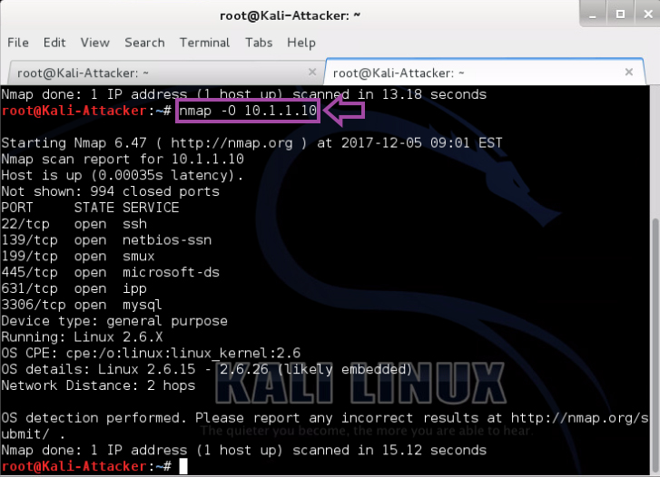

**Notice** next to the Running line, the output may list the operating system and version number. If it does, make note of this information and move on to the next IP address until they are all complete.

4). You may come across a device that does not list the desired information such as the following:

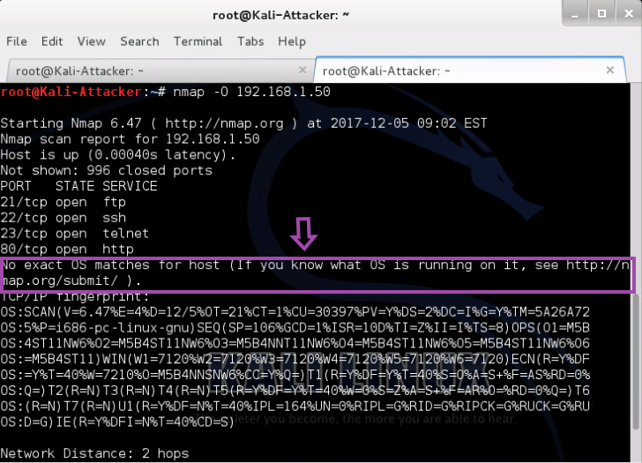

5). To gather more information about the same host, **make** Nmap take approximate guesses as to what the OS may be by using the command below with an included script. **Type** the following command and **press** Enter. (Replace the IP address with that of the one we are looking for more information on):

root@Kali-Attacker:~# nmap –O --osscan-guess 192.168.1.50

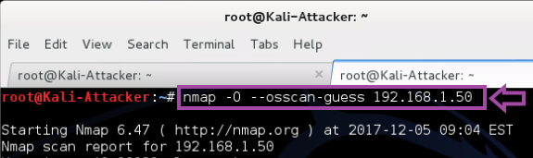

6). **Notice** next to the Running line, it now says Running (JUST GUESSING). This should give an idea of what the system is running but is important to make note that it is just a guess by the scanner.

7). Repeat this step for each of the IP addresses that were used during the port scanning section.

**This completes the procedure for device scanning**.

Vulnerability Assessment/Penetration Testing:

NSSD utilizes OpenVAS and the Greenbone Security Assistant to perform Vulnerability assessments. The Greenbone Security Assistant scans the network to look for vulnerabilities and compares it against its’ database of more than 50,000 known vulnerabilities. The report it generates is then analyzed to check for anything that may need to be fixed. OpenVAS works on a loopback interface to ensure there is always a connection available while the program works. First, we must enable this loopback interface and then start OpenVAS before moving to the Greenbone Security Assistant to perform our scan. To do this, follow these steps:

1). 1). While on the Kali system, **open** a new terminal window.



2). In the terminal window, **use** the ifconfig command to bring the loopback interface to an up state. **Type** the command below in the terminal and **press** Enter.

root@Kali-Attacker:~# ifconfig lo up



3). **Verify** that the loopback is now active. **Type** the following command and **press** Enter.

root@Kali-Attacker:~# ifconfig

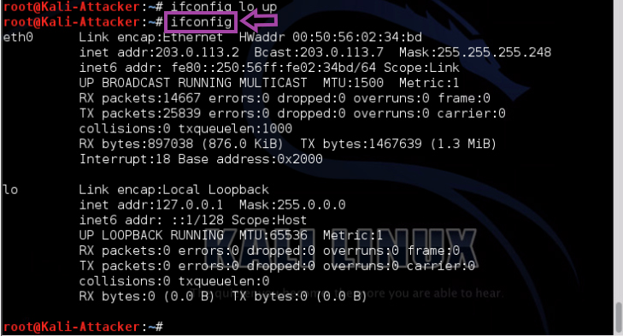

4). **Initiate** the openvas_start script to initialize the OpenVAS Network Scanning application. **Type** the following command and **press** Enter.

root@Kali-Attacker:~# /home/scripts/openvas_start

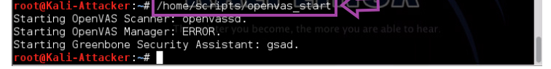

Ignore the error status on the OpenVAS Manager.

5). Once you receive the user prompt back, **open** the Iceweasel Web browser by **clicking** on the icon located on the top menu pane.

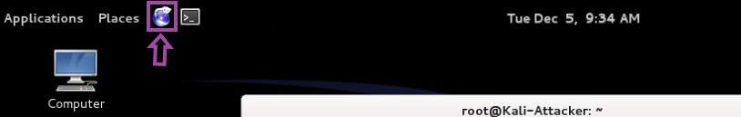

6). Within the Web browser, in the address bar, **type** https://127.0.0.1:9392. **Press** Enter.

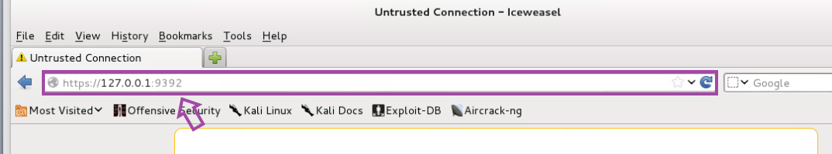

7). **Expand** I Understand the Risks.

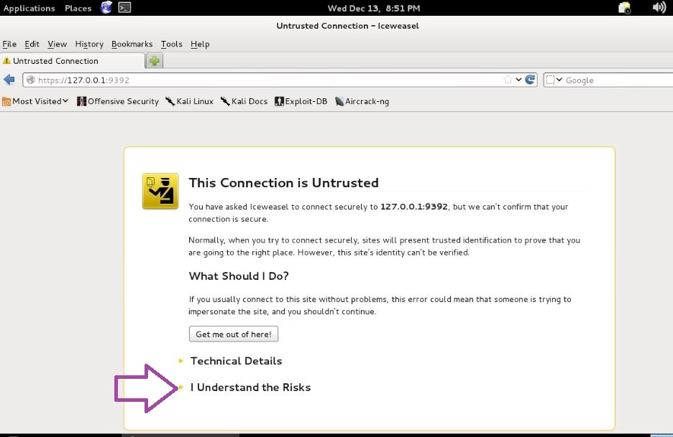

8). **Click** Add Exception.

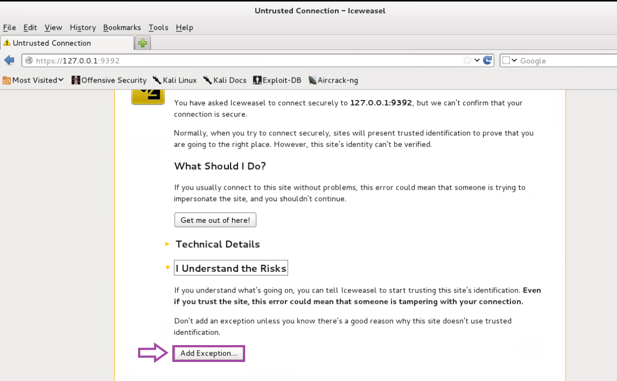

9). **Click** Confirm Security Exception.

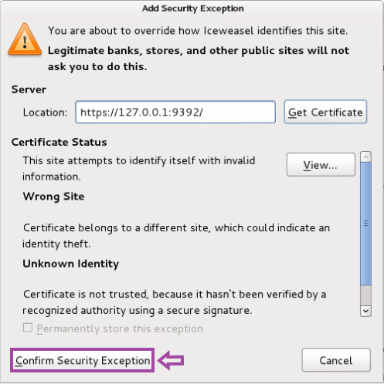

10). At the login prompt, **Type** admin as the Username, and **Type** admin as the password. **Click** Login.

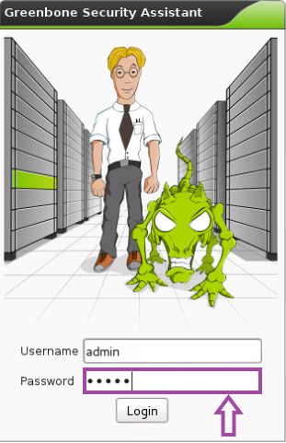

11). Upon login, you will be presented with the homepage for the OpenVAS management dashboard. Underneath Quick start, **type** the IP address of the system you wish to check, in this example we will be using the IP Address 10.1.1.10, **click** the Start Scan button to initialize a default quick scan.

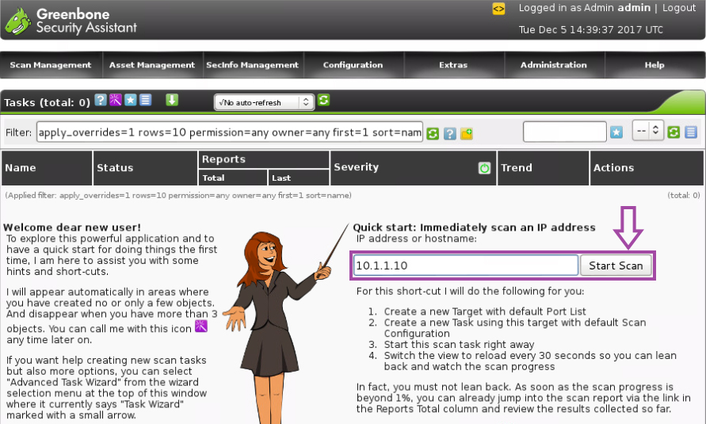

12). This scan will take some time, you can view the status of the scan on homepage under the Status. This will begin as Requested, and then move to showing a progress bar. Once this progress bar shows Done, you can **view** the report by **clicking** on the number under the Total Reports Column.

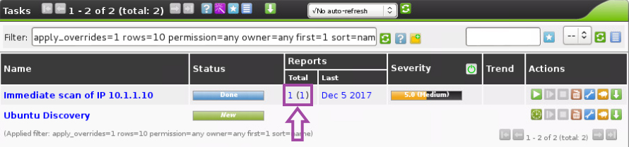

**This completes the procedure for Performing the Vulnerability Assessment.**

Interpreting Vulnerability Assessment Report/Identifying Weaknesses:

The last step in the Vulnerability Assessment process is interpreting the results of the report generated once the scans are complete. The Greenbone Security Assistant generates an easy-to-read report that breaks down the vulnerabilities it found and sorts them based on their severity. This section breaks down the different information you will find in the report to aid in interpreting the results. The report screen will look like the screenshot shown below:

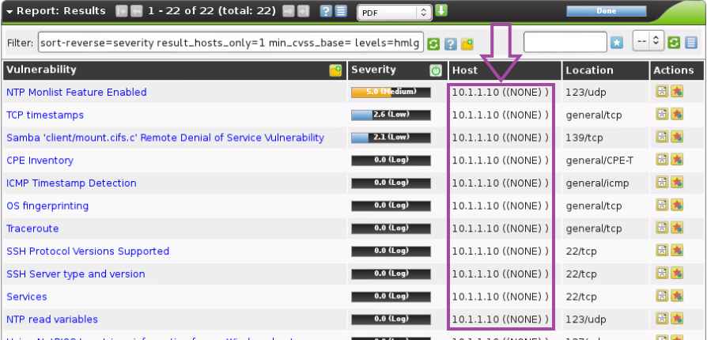

This report screen displays a list of vulnerabilities followed by the severity level of the vulnerability (sorted from highest vulnerability to lowest), the Host (IP Address) that the vulnerability was found on, the location of the vulnerability, and finally presents some actions that can be performed.

To interpret the results, note the following information:

* **Multiple findings can have the same cause.**

If an especially old software package is installed, often multiple vulnerabilities exist. Each of these vulnerabilities is tested by an individual VT and causes an alert. The installation of a current package will remove a lot of vulnerabilities at once.

* **Critical [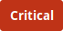](https://docs.greenbone.net/GCS-Manual/gcs/en/_images/critical.png) and Medium [](https://docs.greenbone.net/GCS-Manual/gcs/en/_images/medium.png)**

Findings of the severity levels *Critical* and *Medium* are most important and should be addressed with priority. Before addressing medium level findings, critical level findings should get addressed. Only in exceptional cases this approach should be deviated from, e.g., if it is known that the high level findings need to be less considered because the service cannot be reached through the firewall.

* **Low [](https://docs.greenbone.net/GCS-Manual/gcs/en/_images/low.png) and Log [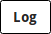](https://docs.greenbone.net/GCS-Manual/gcs/en/_images/log.png)**

Findings of the severity levels *Low* and *Log* are mostly interesting for detail understanding. These findings are filtered out by default but can hold very interesting information. Considering them will increase the security of the network and the systems. Often a deeper knowledge of the application is required for their understanding. Typical for a result with the severity *Log* is that a service uses a banner with its name and version number. This could be useful for an attacker when this version has a known vulnerability.

**A sidenote on False Positives**:

A false positive is a finding that describes a problem that does not really exist. Vulnerability scanners often find evidence that points at a vulnerability but a final judgment cannot be made. There are two options available:

* Reporting of a potentially non-existent vulnerability (false positive).
* Ignoring reporting of a potentially existing vulnerability (false negative).

Since a human is able to recognize false positives and thus manage and deal with them – which is not the case for false negatives – the appliance’s vulnerability scanner reports all potentially existing vulnerabilities. If false positive messages are known to exist, an override can be configured (address this in when reporting your findings to management and the IT department).

**All vulnerabilities** that have a severity greater than 0 should be reported to management and the IT department to begin the process of implementing a solution to resolving this vulnerability. NSSD strives to maintain a secure network to protect its assets, data, and customers. As a result, all results should be reported and addressed with the management team.

# Section Five: Network Scanning

Network Scanning Processes:

To supplement the vulnerability scanning tools we discussed in the previous section, NSSD implements Intrusion Detection tools to monitor and notify security personnel in the event of any suspicious activity on the network. The discovery of rogue devices and malicious connections is handled by SNORT, the Intrusion Detection System, installed on the company network. For viewing and analyzing the network topology, NSSD utilizes the functions of Zenmap to carry out this process and provide a visual representation of the network topology. This section will demonstrate how to perform these tasks and access the reports they generate. The next section will provide advice on interpreting these reports.

**Detecting Rogue Devices and Malicious Connections with SNORT**:

1). For this section, we will be using the **Ubuntu workstation** on the company network. Login to the workstation with the provided password.

**Password to workstation**: P@ssw0rd

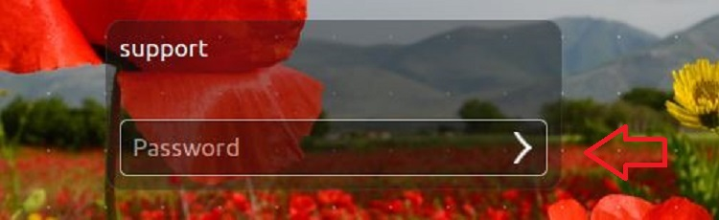

2). **Click** the terminal icon on the launcher.



*SNORT is already installed on the company systems; we will use this Intrusion Detection Software to establish rules to notify security personnel when specific devices or packet types are detected on the network. *

3). **Execute** the following command to **open** local.rules into nano.

support@IDS-DMZ:~$ sudo nano /etc/snort/rules/local.rules

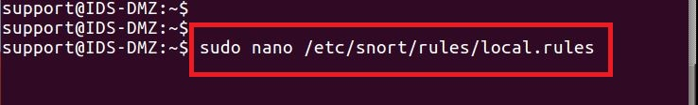

SNORT rules are comprised of two sections: header and options. The rule’s header consists of a rule’s action, protocols, and ports. SNORT rule options are considered informational but can also be used by systems to determine what actions should be taken. Options are encapsulated within parentheses, where each option is separated by a colon, followed by a user-defined variable, and terminated with a semicolon. In this section, we will create a SNORT rule that contains of both the header and options sections.

SNORT can be used to configure an alert to detect when TCP, UDP, or ICMP communication between specific hosts or networks based on IP address. With this, the following examples are provided to work off to create rules based on what we are looking to detect and the alerts we want generated when an attempt to connect to a specific host is made. The following examples provide examples of rules to detect TCP, UDP, and ICMP connections.

**TCP communication**

To detect TCP communication between hosts specify ip_proto:tcp; and flags:S as the attack parameters.

**Example:**

alert tcp 10.1.1.10 any -> [192.168.230.0/24, 192.168.231.0/24] any (msg:”Malicious TCP Traffic”;ip_proto:tcp;flags:S;sid:3121;)

Here 10.1.1.10 is an example source IP and [192.168.230.0/24, 192.168.231.0/24] are the example destination subnets.

If you do not specify flag:S the rule is triggered for all the TCP packets between the specified hosts.

**UDP communication**

To detect UDP communication between hosts, specify ip_proto:udp; as the attack parameter.

**Example:**

alert udp 10.1.1.10 any -> [192.168.230.0/24, 192.168.231.0/24] any (msg:”Malicious UDP Traffic”;ip_proto:udp;sid:3122;)

Here 10.1.1.10 is an example source IP and [192.168.230.0/24, 192.168.231.0/24] are the example destination subnets. The Sensor sends alerts for any UDP packet detected between the specified hosts.

**ICMP communication**

To detect ICMP communication between hosts, specify ip_proto:icmp; as the attack parameter.

**Example:**

alert ip 10.1.1.10 any -> [192.168.230.0/24, 192.168.231.0/24] any (msg:”Malicious ICMP Traffic”;ip_proto:icmp;sid:3123;)

Here 10.1.1.10 is an example source IP and [192.168.230.0/24, 192.168.231.0/24] are the example destination subnets.

In the rule, use the following parameters along with icmp for a more specific detection:

itype - Use this to check for a specific ICMP type value:

Syntax: itype:[<|>]<number>[<><number>];

icode - Use this to check for a specific ICMP code value.

Syntax: icode: [<|>]<number>[<><number>];

**Example:**

alert icmp 10.1.1.10 any -> [192.168.230.0/24, 192.168.231.0/24] any (msg:"example for itype and icode"; itype 8; icode:0; sid:2022; priority:3;)

Here 10.1.1.10 is an example source IP and [192.168.230.0/24, 192.168.231.0/24] are the example destination subnets. This rule is triggered for inbound traffic where the type is 8 and code is 0.

A basic rule to alert to any ICMP traffic on the network follows. This is intended to show how to save and verify the rule syntax is correct in SNORT through the command line. This can be combined with the previous examples to alert to any connections based on the specific hosts the employee desires. Company host IP addresses can be looked up and used by employees to create rules following the example structures and the following example of the process.

4). **Add** the following rule, which states, send an ALERT message when an ICMP packet is received from ANY source socket (any IP any port) going to ANY destination socket (any IP any port).

### TEST DETECTION USING SNORT HEADER ATTRIBUTES

alert icmp any any -> any any

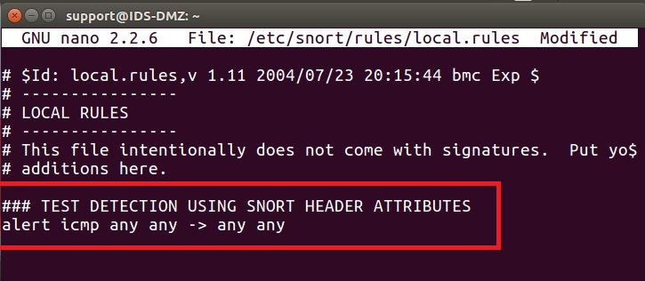

5). **Press** and **hold** the Ctrl key followed by **pressing** the x key to Exit.

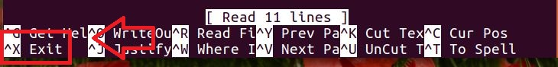

6). **Press** the y key to confirm exit.

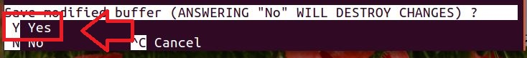

7). **Press** the Enter key to confirm file.

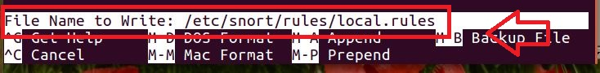

8). **Execute** the following command to **verify** rule syntax.

support@IDS-DMZ:~$ sudo snort –c /etc/snort/snort.conf –T

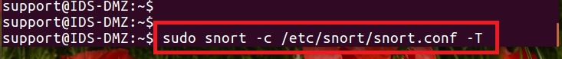

9). **Verify** that you **see**the following message indicating proper syntax.

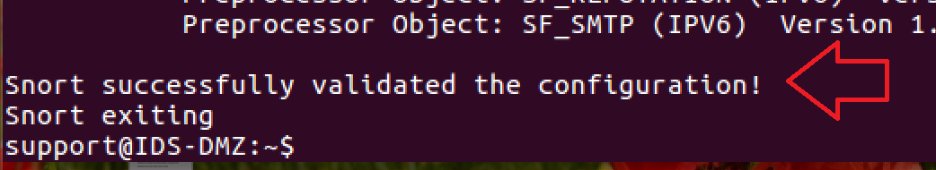

These rules can be supplemented with options as previously stated. The rules are confirmed and verified the same way as in the previous example. The following example shows an example of a rules created with both header and options sections. This coincides with the text examples provided earlier in this section regarding TCP, UDP, and ICMP connections.

10). **Add** the following rule, which states, **send** an ALERT message when a TCP packet is **received** from ANY source socket (any IP any port) going to the destination socket (10.10.1.114:443). Both of these options instruct the alerting engine to print the option values within the message.

# CREATING A RULE COMPRISED OF BOTH HEADER AND OPTIONS SECTIONS

alert tcp any any -> 10.10.1.114 443 \

(msg:"Priority 1 IDS-DMZ"; sid: 1000100;)

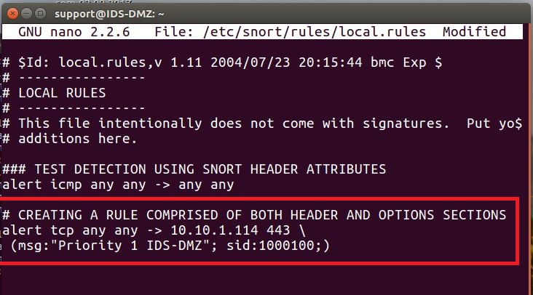

These rules can be created for any data type and monitored on any host on the network to alert to any attempts made to send packets to hosts.

**This ends the section on establishing SNORT rules for detection**.

Viewing Network Topologies:

It is important to keep track of the network topology as new devices are added to the network to ensure no vulnerable spots are left open. Along with this, making sure no unintended ports are left open ensures that the company network does not remain vulnerable to attack through a port that was never intended to be usable. There are 65,535 ports available on any given network. While a large majority of these are not used, leaving unused ports open can leave an avenue of attack on the companies’ network. NSSD utilizes Zenmap to trace the network topology and display it in an easy to view illustration of the layout. This program also serves to detect information about each network host for analysis.

1). Begin by logging into the Kali Linux Virtual Machine, when presented with the username, **type** root. **Press** Enter.

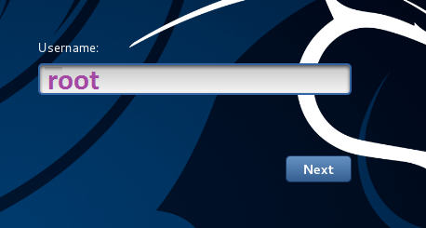

2). When prompted for the password, **type** toor. **Click** the Sign In button.

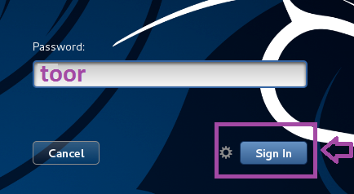

3). **Click** the black and white icon (second from the top) to launch the Linux terminal.

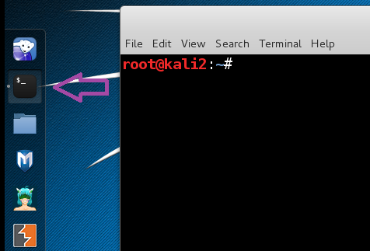

4). **Type** the following command, then **press** Enter, to open Zenmap. After Zenmap opens, **type** 192.168.1.* in the Target box and then **click** the Scan button to launch an intense scan.

root@kali2:~# zenmap

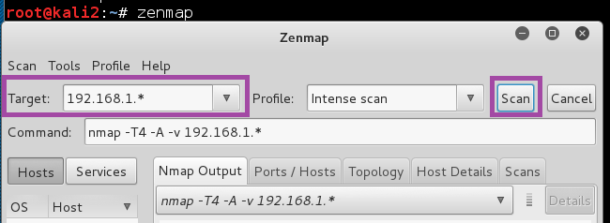

*Note: This scan will take a while to complete. The words Nmap done will be displayed when finished. *

5). After the scan is complete, all hosts will be displayed in the left panel of Zenmap. In the following example, there are five hosts, your scan will have more.

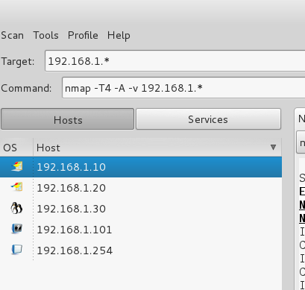

6). **Click** on the Topology Tab. This tab shows a visual representation of the network topology of all the hosts on the network. This gives you an idea of how the network is set up. Keep track of this with a screen shot to use as reference when making regular scans to compare and check for any new devices. Ensure any new devices are authorized based on IP address by referencing the company approved device log.

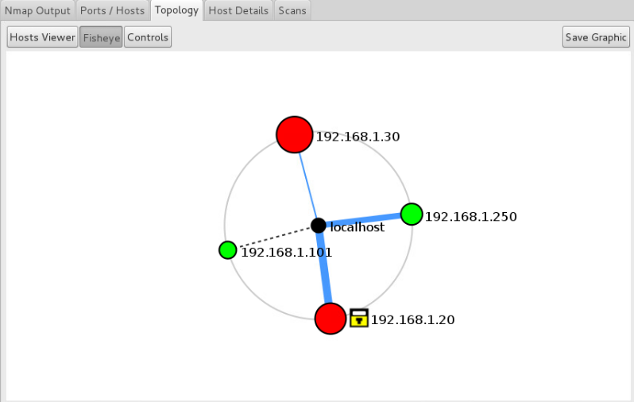

7). Next, **Click** on each host and **click** the Ports / Hosts tab to view the open ports and corresponding banner messages that are displayed.

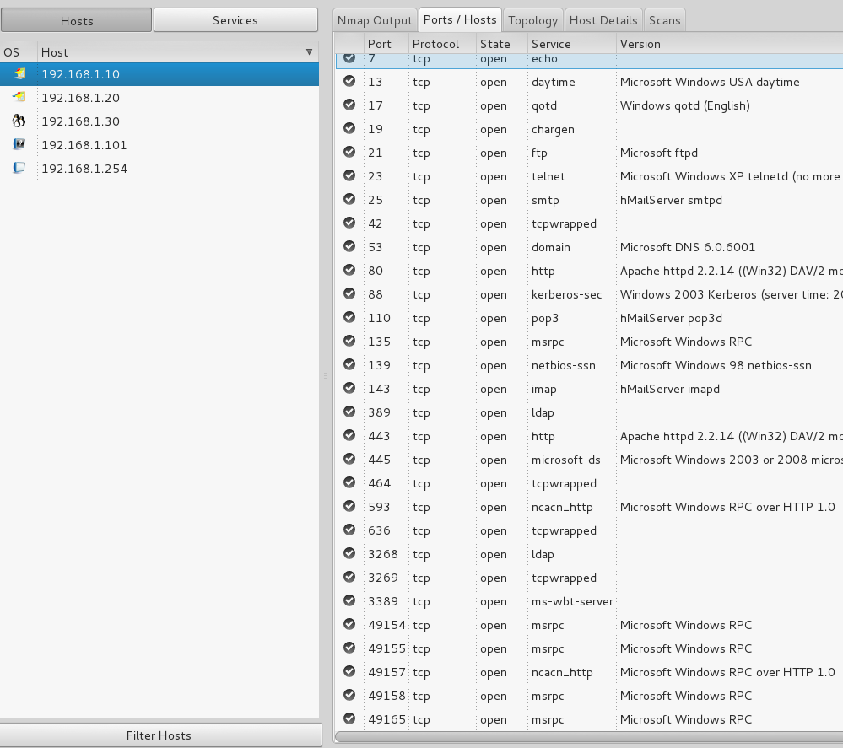

**This ends the section on viewing network topology and port security**.

Network Scanning Interpretation:

It is important to view the open ports tab from Zenmap and ensure none of the open ports listed on each host are not meant to be open. This can be a time-consuming task depending on the number of hosts on the network but any host with an unintended open port leaves the entire network vulnerable to attack. View each hosts ports list like the following screenshot:

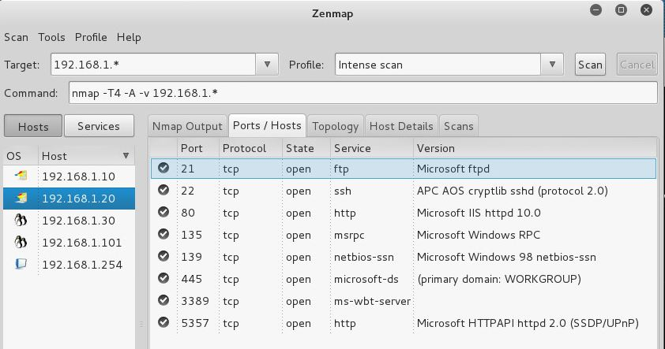

**Note** the port numbers and the states. **Locate** the company authorized and intended open port document that lists all the approved ports. Compare the ports listed on this document to the open ports on each host to ensure no port is open that is not meant to be. If one is found, immediately notify management and a member of the network security team.

Lastly, SNORT alerts are logged on to the syslog server. This server is located on the same device as the web server. When viewing these alerts, it is important to note the information generated. The following screen shot is an example of ICMP alerts generated by SNORT:

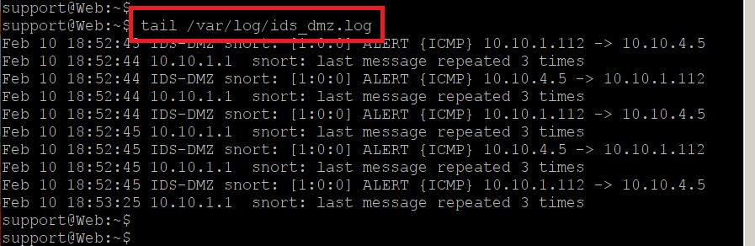

When viewing these messages, there are some notable pieces to analyze. Each alert will display the alert type. In the provided example, you can see immediately following ALERT is the ICMP tag. This will change based on the rules set in SNORT and the type of alert generated. Following this information, you will see the path of communication. In the example, host 10.10.1.112 sent ICMP traffic to 10.10.4.5. Finally, it lists the number of times the message was repeated. This information can be used to determine what traffic is most commonly being sent to specific hosts. With this information, you can determine the common targets of suspicious traffic to then know where the primary focus needs to be.

# Section Six: Auditing and Log Collection

Auditing Tools:

NSSD uses GREP on a Security Onion system to hold logs. To view these, follow these steps.

1). Login to the Security Onion system. On the login screen, **type** soadmin. **Press** Enter.

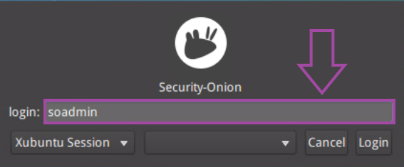

2). When prompted for the password, **type** mypassword. **Press** Enter.

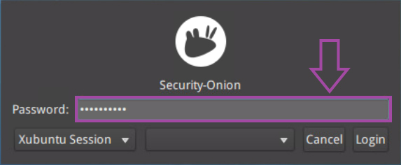

3). **Open** a new terminal window by **double-clicking** the terminal icon.

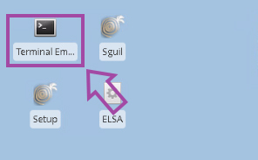

5). **Change** the current directory to /var/log/nginx. **Type** the following command and **press** Enter.

soadmin@Security-Onion:~$ cd /var/log/nginx

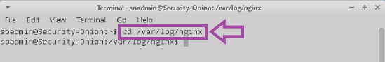

6). **View** the access_log by typing the command below. **Press** Enter.

soadmin@Security-Onion:/var/log/nginx$ cat access.log

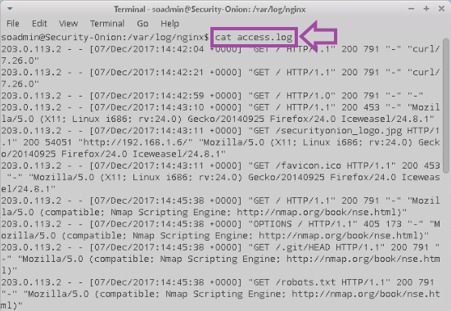

7). Log files can be very large, you can use commands to search for the information you are concerned with if you are looking for something specific. To do this, modify the command to narrow down the output. The following example uses Nmap as the search term.

**Type** the following command and **press** Enter.

soadmin@Security-Onion:/var/log/nginx$ cat access.log | grep Nmap

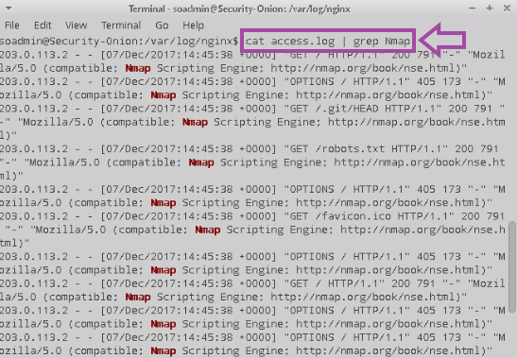

This can be used with whatever the focus of the search is. I.e., Firefox, Curl, Nmap, whatever you are trying to narrow down.

Recommended Network Tools Overview and Rationale:

Each tool selected by NSSD is meant to serve a purpose. All the tools combine to give the company a strong security posture while addressing key areas of vulnerability and protecting the company network from unauthorized access. As a software development company, North Star Software Developers (NSSD) has a responsibility to its shareholders and its customers to protect any sensitive information and data assets that are shared with the company.

Wireshark:

Wireshark is a network protocol analyzer often called a packet sniffer. It allows you to inspect and capture packets on your network. It allows you to inspect the traffic that is transmitting on your network. Wireshark provides a user interface that allows you to filter your network traffic and analyze that traffic. A system administrator can use Wireshark if he or she suspects there might be nefarious traffic that the firewall and/or intrusion detection system is not catching. Packet sniffing is the practice of observing, collecting, and logging data packets flowing through a network. The goal of sniffing is to monitor and scan the data entering and leaving the network to "sniff out" malicious or problematic data flow. By analyzing captured data packets using Wireshark, you’ll gain information on how and when data moves around in your network and whether there’s any activity you don’t recognize.

Wireshark can be used for both real-time network analysis and troubleshooting, as well as offline and post-incident. Using live data filters, Wireshark slices and divides all captured data into categories that meet your specific search criteria. For this reason, Wireshark is a powerful tool that gives employees the ability to monitor the company network and look for any malicious traffic that has been missed by the Intrusion Detection system. Understanding how Wireshark works and the type of data and insights it offers can help you understand the bigger picture of network security and optimization.

Network Miner:

Network miner is Network Forensic Analysis tool (NFAT) that runs on Windows, Linux, and MacOS X. It can be used as a passive packet sniffer or a network analysis tool using PCAP files. Network Miner can extract artifacts, such as images, files, e-mails, certificates, credentials, cookies, passwords, and other artifacts using a PCAP file or by directly sniffing network traffic. Detailed information about each IP address in the analyzed network traffic is aggregated to a network host inventory, which can be used for passive asset discovery as well as to get an overview of which devices are communicating.

By utilizing Network Miner, employees can take PCAP files that have been flagged as suspicious and extract any information they can to determine the contents of the traffic. By analyzing the contents of the traffic, evidence can be collected to allow the company to respond to potential attacks as well as prevent malicious actions taken across the network.

Nmap/Zenmap:

Nmap (“Network Mapper”) is an open-source tool for network exploration and security auditing. It was designed to rapidly scan large networks, although it works fine against single hosts. Nmap uses raw IP packets in novel ways to determine what hosts are available on the network, what services (application name and version) those hosts are offering, what operating systems (and OS versions) they are running, what type of packet filters/firewalls are in use, and dozens of other characteristics. While Nmap is commonly used for security audits, many systems and network administrators find it useful for routine tasks such as network inventory, managing service upgrade schedules, and monitoring host or service uptime. The output from Nmap is a list of scanned targets, with supplemental information on each depending on the options used. Key among that information is the “interesting ports table”. That table lists the port number and protocol, service name, and state. The state is either open, filtered, closed, or unfiltered. Open means that an application on the target machine is listening for connections/packets on that port. Filtered means that a firewall, filter, or other network obstacle is blocking the port so that Nmap cannot tell whether it is open or closed. Closed ports have no application listening on them, though they could open up at any time. Ports are classified as unfiltered when they are responsive to Nmap's probes, but Nmap cannot determine whether they are open or closed. Nmap reports the state combinations open|filtered and closed|filtered when it cannot determine which of the two states describe a port. The port table may also include software version details when version detection has been requested. When an IP protocol scan is requested (-sO), Nmap provides information on supported IP protocols rather than listening ports.

Zenmap is the official Nmap Security Scanner GUI. It is a multi-platform free and open-source application which aims to make Nmap easy for beginners to use while providing advanced features for experienced Nmap users. Frequently used scans can be saved as profiles to make them easy to run repeatedly. A command creator allows interactive creation of Nmap command lines. Scan results can be saved and viewed later. Saved scan results can be compared with one another to see how they differ. The results of recent scans are stored in a searchable database.

By utilizing Nmap and Zenmap, employees gain an overview of the company network including the network topology along with the ability to determine the port status of any device on the network. With this information, employees can address key vulnerabilities created by unauthorized open ports leaving back doors onto the company network.

Greenbone Security Assistant/ OpenVAS:

The Greenbone Security Assistant is a web application that connects to the OpenVAS Manager and OpenVAS Administrator to provide for a full-featured user interface for vulnerability management. OpenVAS (Open Vulnerability Assessment System) is used to audit the security of an internal corporate network and find vulnerabilities in a free and automated fashion. OpenVAS allows regularly assessing a corporate network for vulnerabilities and alerts IT professionals when a major change or new vulnerability has been introduced into the enterprise. The Greenbone Security Assistant serves as an easier alternative to the command line client to control the scanner, schedule scans and view reports.

By using the Greenbone Security Assistant to manage and configure OpenVAS, employees can regularly assess the company’s network to detect any known vulnerabilities based on the database contained within OpenVAS. The assistant packages the scan results in an easy-to-read report to identify any vulnerabilities on the network and allow them to be addressed by the security team.

pfSense:

pfSense is an open-source firewall/router. It is very versatile and offers a number of modules such as snort. pfSense supports not only firewall and routing functionality and virtual private network functionality but also intrusion prevention system functionality. In addition to being a powerful and flexible firewall and router platform, it has a long list of features and a package system, which is quite advantageous. This package system not only gives the operating system the flexibility to expand but also prevents security holes in distribution.

pfSense serves as the main firewall for NSSD. With it, employees can create and set up specific rules depending on the application being sought. Port Forwarding, opening, and closing ports, traffic control, all the features of a firewall located in one place, accessible from anywhere in the company. This firewall serves as the main line of defense for the company and its ability to be coupled with its offered software packages allow for the software to be augmented to increase its capabilities.

Snort:

SNORT is a powerful open-source intrusion detection system (IDS) and intrusion prevention system (IPS) that provides real-time network traffic analysis and data packet logging. SNORT uses a rule-based language that combines anomaly, protocol, and signature inspection methods to detect potentially malicious activity. Using SNORT, network admins can spot denial-of-service (DoS) attacks and distributed DoS (DDoS) attacks, Common Gateway Interface (CGI) attacks, buffer overflows, and stealth port scans. SNORT creates a series of rules that define malicious network activity, identify malicious packets, and send alerts to users. Snort is one of the packages that can be implemented into the pfSense firewall. It can be configured to simply log detected network events to both log and block them. Thanks to OpenAppID detectors and rules, Snort package enables application detection and filtering.

By implementing Snort in conjunction with the pfSense firewall, any shortcomings the firewall has are then covered by the Intrusion Detection System to alert to any infiltration past the firewall. Snort’s use of rule sets allows the company to pay a subscription to receive twice weekly updates to rules sets such as the GPLv2 community rules and the emerging threats pro rules. This keeps the IDS up to date to respond to the latest threats that get past other layers of security.

# Works Cited

Cichonski, P., Millar, T., Grance, T., & Scarfone, K. (2012, August). *Computer Security Incident Handling Guide.* Retrieved from National Insitute of Standards and Technology: https://nvlpubs.nist.gov/nistpubs/specialpublications/nist.sp.800-61r2.pdf

Grimmick, R. (2021, August 5). *Packet Capture: What is it and What You Need to Know*. Retrieved from Varonis: https://www.varonis.com/blog/packet-capture

Keary, T. (2022, November 2). *PCAP: Packet Capture, what it is & what you need to know*. Retrieved from Comparitech: https://www.comparitech.com/net-admin/pcap-guide/

Chen, Y. (2018). Network security technologies and solutions. CRC Press.

Kabay, M. (2020). Network security essentials: Applications and standards. John Wiley & Sons.

ISO. (2019). ISO/IEC 27005:2018 - Information technology -- Security techniques -- Information security risk management. ISO.

NIST. (2020). NIST SP 800-30, Guide for Conducting Risk Assessments. National Institute of Standards and Technology.

NIST. (2016). NIST SP 800-61 Rev. 2 Computer Security Incident Handling Guide. National Institute of Standards and Technology.

SANS Institute. (2020). Incident Response: A Strategic Guide to Handling System and Network Security Breaches. SANS Institute.